**DAILY ONLINE ACTIVITIES SUMMARY**

|  |  |  |  |  |  |  |  |  |
| --- | --- | --- | --- | --- | --- | --- | --- | --- |
| **Date:** | **22-5-2020** | | | | | **Name:** | **Prajna** | |
| **Sem & Sec** | **8th sem ‘B’** | | | | | **USN:** | **4AL16CS067** | |
| **Online Test Summary** | | | | | | | | |
| **Subject** | | **BDA** | | | | | | |
| **Max. Marks** | | **40** | | **Score** | | | **29** | |
| **Certification Course Summary** | | | | | | | | |
| **Course** | **Getting started: Hadoop** | | | | | | | |
| **Certificate Provider** | | | **Great Learning** | | **Duration** | | | **30min** |
| **Coding Challenges** | | | | | | | | |
| **Problem Statement:**1**.** Write a c program to find missing number in a array.. | | | | | | | | |
| **Status: Completed** | | | | | | | | |
| **Uploaded the report in GitHub**  **GitHub link:** | | | | | **Yes**  **https://github.com/alvas-education-foundation/prajna_k** | | | |
| **If yes Repository name** | | | | | **prajna_k** | | | |
| **Uploaded the report in slack** | | | | | **yes** | | | |

Online Test Details: (Attach the snapshot and briefly write the report for the same)

Certification Course Details: (Attach the snapshot and briefly write the report for the same)

Coding Challenges Details: (Attach the snapshot and briefly write the report for the same)

1)online test

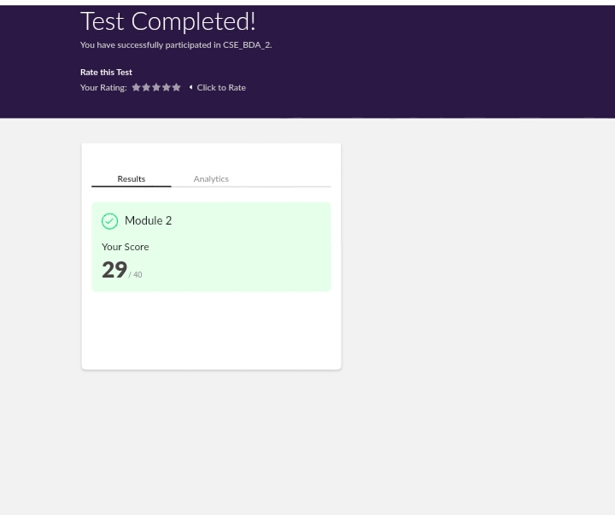

2) certification course

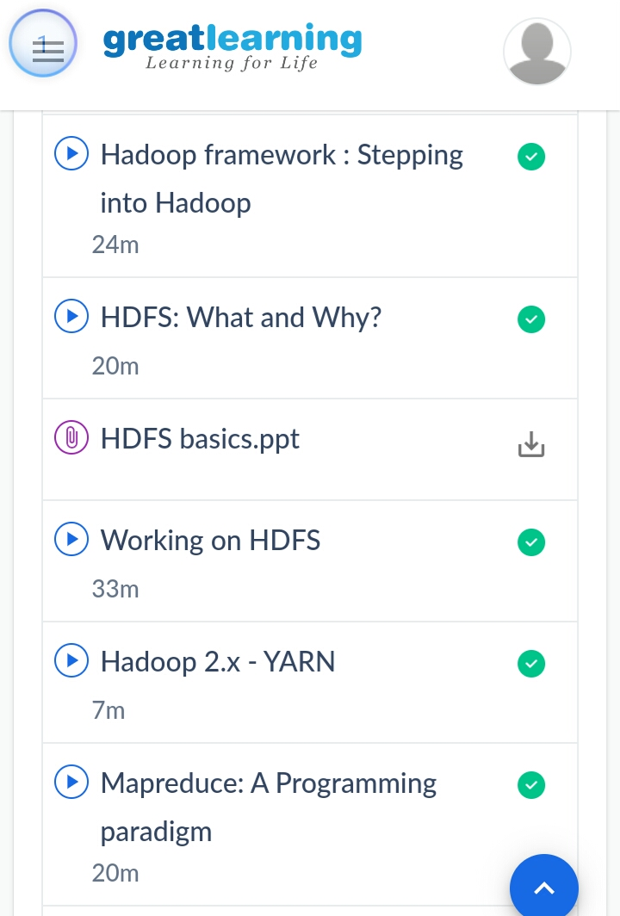

3) coding challenges

Program 1

|  |
| --- |
|  |
|  |  |
|  |  |
|  |  |
|  |  |
|  |  |

#include <stdio.h>

int getMissingNumber(int *array, int size) {

    int i, sum = 0, n = size + 1;

    /* Take the sum of all array elements */

    for(i = 0; i < size; i++){

        sum = sum + array[i];

    }

   return (n*(n+1))/2 - sum;

}

int main(){

 int array[8] = {1, 4, 6, 2, 5, 8, 7, 9};

 printf("Missing Number : %d \n", getMissingNumber(array, 8));

 return 0;